**DSPMU UNIVERSITY, RANCHI.**

**DEPARTMENT OF GEOLOGY**

**M.Sc. SEMESTER-III**

**ELEMENTS OF PHOTO INTERPRETATION**

Image interpretation is a powerful technique which enables us to identify and distinguish various features in remote sensing images/Aerial photos and allows gaining the knowledge and information about them. Analysis of remote sensing image often involves identification of various features such as forest cover, water bodies, urban settlement, agriculture and range land etc. These features are identified by the way they reflect or emit radiations and also by their association and location. These radiations are measured by satellite/Aerial sensors and ultimately depicted in the form of satellite image or aerial photo. Visual interpretation of aerial photographs involves the study of various basic characteristics of an object. In case of interpretation of satellite images, these characteristics of objects are studied with reference to a single or multiple spectral bands because there are generally more than one images acquired in different spectral regions of electromagnetic spectrum.

**Tone** refers to the colour or relative brightness of an object in colour image and the relative and quantitative shades of grey in black and white image. The tonal variation is due to the reflection, transmission or absorption characteristic of an object. This may vary from one object to another and from one band to another. Tone is one of the most basic elements because it is difficult to discern other elements without tonal differences.

In general, smooth surface tends to have high reflectance than rougher surface with less reflectance. Strong tonal contrasts on satellite imageries are always desirable for better image interpretation. Similarly, in thermal imagery, objects at higher temperature are recorded in lighter tone compared to objects at lower temperature, which appear of medium to darker tone. Similarly, top soil gives dark tone compared to soil containing quartz (silica) sand.

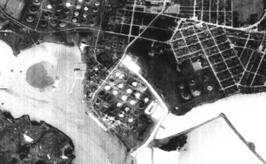

Tone can be exhibit here in the visual contrast between objects and features in this image.

**Size** of objects in an image is a function of scale hence, the size of objects must be considered in the context of the scale of a photograph/image. Although, the third dimension, which comprises of height of the objects is not readily measurable on satellite images but valuable information can be derived from the shadows of the objects. Size of an object can be important tool for its identification, in two ways. First, the size of an object or feature is relative in relation to other objects on the image. This is probably the most direct and important function of size, as it provides the interpreter with an intuitive notion of the scale and resolution of an image even though no measurements or calculations may have been made. This role is achieved by recognition of familiar objects like dwellings, highways and rivers as shown in Fig. Second, absolute measurement can be equally valuable as interpretation aids. You should remember that size of an object in an image depends on the scale and resolution of the image.

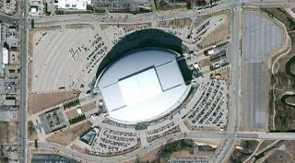

**Shape** relates to the general form, configuration or outline of an individual object. Shape is one of the most important single factors for recognising objects from images (Fig.). Regular geometric shapes are usually indicators of human presence and use. Similarly, irregular shapes are usually indicators of natural objects. Some objects can be identified almost solely on the basis of their shapes. For example, a railway line is usually readily distinguished from a highway or an unmetalled road because its shape consists of long straight tangents and gentle curves as opposed to the shape of highway. You should remember that shape of an object viewed from above may be quite different from its profile view. For planar objects, it is easier to calculate the areal dimensions on imagery e.g., river as shown in Fig. Features in nature often have such distinctive shapes that shape alone might be sufficient to provide clear identification e.g., beach, ponds, lakes and rivers occur in specific shapes unlike others found in nature.

 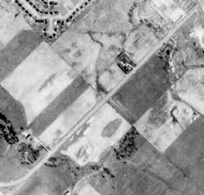

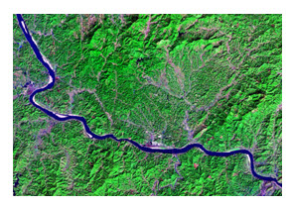 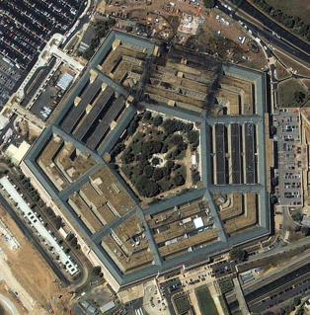

**Texture** is an expression of roughness or smoothness as exhibited by the images. It is the rate of change of tonal values (frequency of tonal changes). Texture signifies the frequency of change and arrangement of tones in an image and is produced by an aggregate of unit features too small to be clearly recognised individually on an image.

Texture can be expressed qualitatively as coarse, moderate, fine, very fine, smooth, rough, rippled and mottled. It is rather easier to distinguish various textural classes visually than in the digital oriented techniques. Texture is, thus, dependent upon tone, shape, size, pattern, and scale of the imagery, and, is produced by a mixture of features that are too small to be seen individually. For example, grass and water generally appear ‘smooth’ while trees or a forest canopy may appear ‘rough’ as shown in Fig.

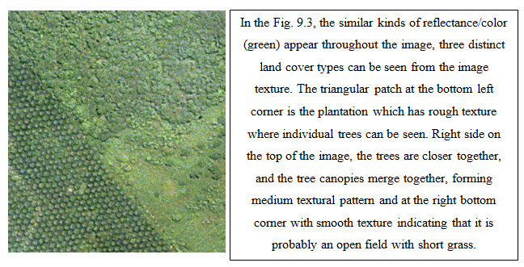

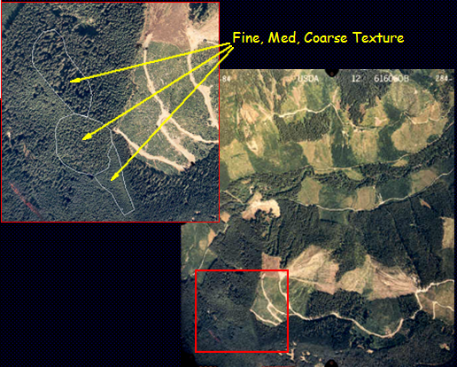

**Association** is occurrence of features in relation to its surroundings. Sometimes a single feature by itself may not be distinctive enough to permit its identification. It specifies the occurrence of certain objects or features in association of a particular object or feature.

Many features can be easily identified by examining the associated features. For example, a primary school and a high school may be similar flat roofed building structures but it may be possible to identify the high school by its association with an adjacent field.

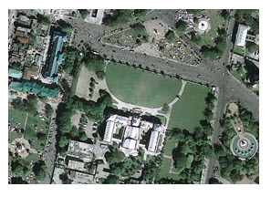

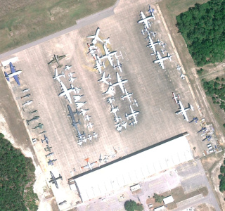

**Shadow** is an especially important clue in the interpretation of objects in the following two ways:

-the outline or shape of a shadow provides a profile view of objects, which aids in image interpretation and

-objects within shadow reflect little light and are difficult to discern on image, which hinders interpretation

Taller features cast larger shadows than shorter features as observed in Fig. 7.9. Military image interpreters are often primarily interested in identification of individual items of equipment. Shadow is significant in distinguishing subtle differences that might not be otherwise visible.

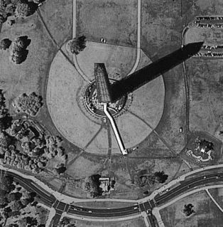 

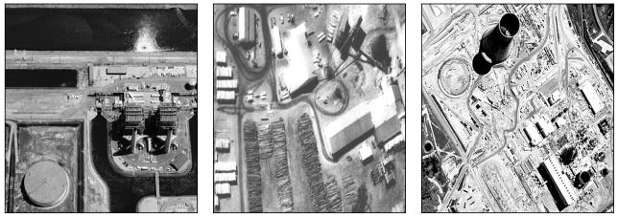

**Site** refers to the topographic position, for example, sewage treatment facilities are positioned at low topographic sites near stream or rivers to collect waste flowing through the system from higher locations. The relationship of feature to the surrounding features provides clues towards its identity. You can also consider the example of certain tree species located in areas of specific altitudes. Similarly, identification of landforms can help in deciphering the underlying geology. Often many of the rock types have distinct topographic expressions, for example, some kinds of sedimentary rocks are typically exposed in the form of alternating ridge and valley topography.

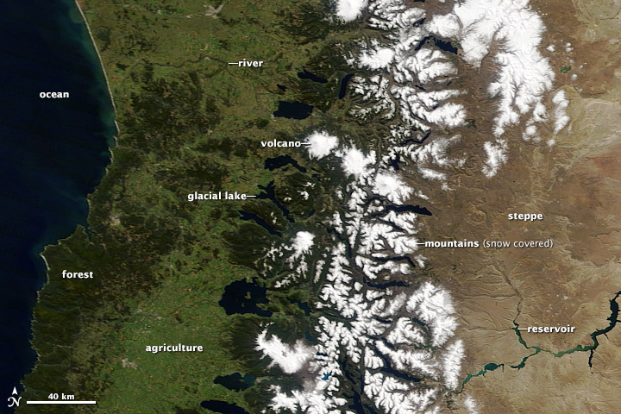

Central Chile and Argentina offer a wide range of geographic features, including snow-covered mountains, canyons, and volcanoes. (NASA [image](http://lance-modis.eosdis.nasa.gov/cgi-bin/imagery/single.cgi?image=Chile.A2013267.1425.2km.jpg) courtesy Jeff Schmaltz [LANCE/EOSDIS MODIS Rapid Response Team,](http://earthdata.nasa.gov/data/near-real-time-data/rapid-response) GSFC.)

**Pattern** refers to spatial arrangement of features or objects in a landscape. A repeated sequence of certain form or relationships is characteristic of many natural and constructed features which give an added advantage to the interpreter.

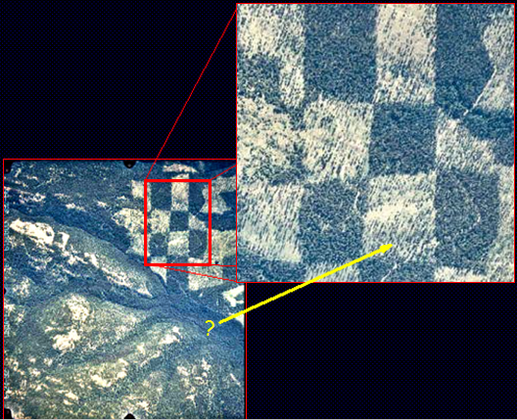

Pattern (in remote sensing) is a recognizable repetition of particular shapes. In this example, the checkerboard pattern of rectangular shapes suggests that this once forested area has been clear-cut along regular boundaries.